**EXPERIMENT 6**

**AIM: Write a program which demonstrates State and Prop in React.**

**CODE:**

**App.js (State):**

import React, { useState } from 'react';

import './App.css'; // Import the CSS file

import ChildComponent from './ChildComponent';

const App = () => {

*// Define state variables*

  const [name, setName] = useState('Alice');

  const [count, setCount] = useState(0);

*// Function to update the count in the state*

  const incrementCount = () => {

    setCount(count + 1);

  };

  return (

    <div className="container">

      <h1>State and Props Demonstration</h1>

*{/* ChildComponent receives props from the parent */}*

      <ChildComponent name={name} count={count} />

*{/* Button to change state */}*

      <button onClick={incrementCount}>

        Increment Count

      </button>

    </div>

  );

};

export default App;

**ChildComponent.js (Props):**

import React from 'react';

const ChildComponent = (props) => {

  return (

    <div>

      <p><span>Name:</span> {props.name}</p>

      <p><span>Count:</span> {props.count}</p>

    </div>

  );

};

export default ChildComponent;

**OUTPUT:**

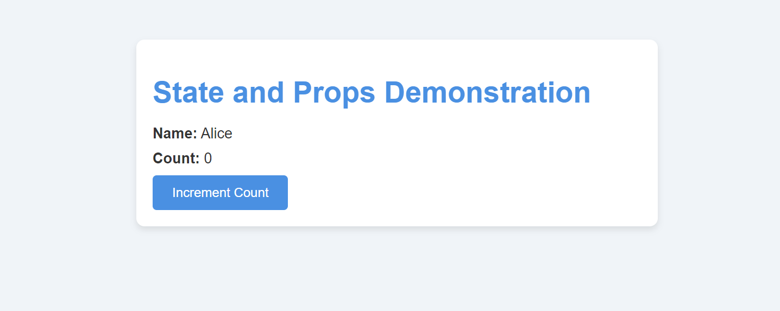

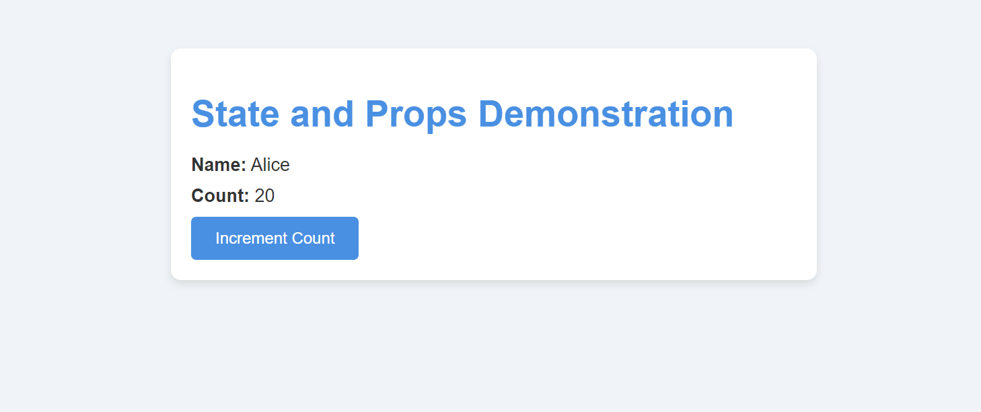

**CONCLUSION: Hence, we have successfully implemented a program which demonstrates State and Prop in React.**